Feedback form - oprichten bv+holding
- Still waiting to solve: multiple new holding, multiple new working, with the cross structure (but can delay until other questions are fixed)
- Aanvraagtype
  - no questions here
- Oprichting document (Holding)
  - first ask the shareholders and then ask about the bv address
otherwise, clients might be confusing about if there aremore naturalijke persoon be one of the shareholders and would like to use thataddress
  - boekhouder/accountant: maybe first ask if they are alreadyworking with a boekhouder/accountant. becuase now it is the "mustanswered"question, but might have someone doesn't haveboekhouder/accountant (the resellers can also be advocaten,etc)
  - bestaande holding can also be the shareholder of the holding
  - I think we can skip this question since in "Aanvraagtype" it has already asked who will be the shareholder of the working bv and if they have already selected the "nieuwe holding" then we don't need this anymore?
- Oprichting document (werkmij)
  - first ask the shareholders and then ask about the bv address
otherwise, clients might be confusing about if there aremore naturalijke persoon be one of the shareholders and would like to use thataddress
  - boekhouder/accountant: maybe first ask if they are alreadyworking with a boekhouder/accountant. becuase now it is the "mustanswered"question, but might have someone doesn't haveboekhouder/accountant (the resellers can also be advocaten,etc)
  - Need to make possible to let the client choose who will be the first shareholder, the bestaande holding or the new holding
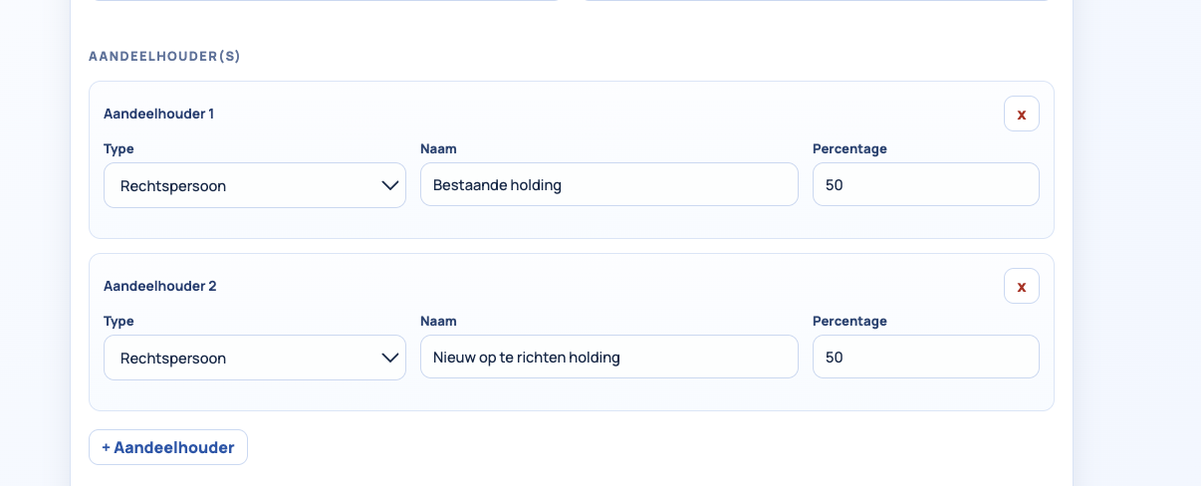
  - KVK inschrijving+detailhandel+groothandel are “required” questons
in this form i see all of them are not "required" questions, I think except "overige" all of them are required questions
- Bestaande holding
  - I tried to fill in 1 rechtspersoon in the new holding and put 1 bestaande holding in the new working bv, but there is only 1 form for bestaande holding, which is not correct.
  - also same question here, bit confused about why there are two forms "bestaande holding" and "Rechtspersoon", I think if we have "rechtspersoon" form and add telefoon nummer, mail adres, adres van de BV then we don't need "bestaande holding"? also need to add the directeur and ask the client to choose if it is natuurlijke persoon or rechtspersoon. because currently i tried to choose "rechtspersoon" as the directeur of the bestaande holding, but was not asked for the information of this "rechtspersoon directeur"
- Rechtspersonen
  - As we said this afternoon, for "nieuw op te richten holding" the client doesn't have the infomation for KVK number, also cannot upload any of the files. So if it is nieuw op te richten holding we don't need to have the "rechtspersonen form"
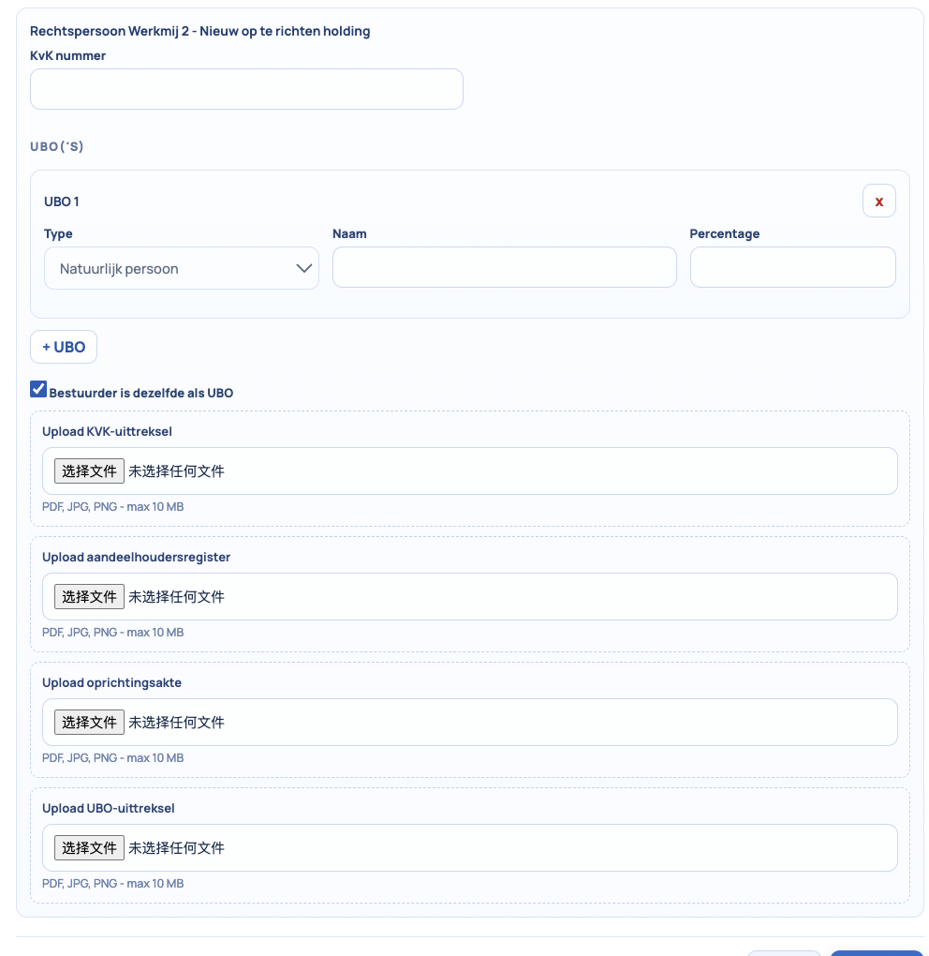
  - There is no "required" questions, so i assume still need to put the red stars
- Natuurlijke personen
  - need to make it impossible to fill in the "Nederland woonadres"
  - need to add a reminder under eenmanszaak "Let op: uw nieuw op te richten B.V. mag niet dezelfde naam hebben als uw bestaande eenmanszaak. Indien beide ondernemingen dezelfde naam hebben, adviseren wij u om de naam van uw eenmanszaak via het online formulier van de Kamer van Koophandel (KVK) te wijzigen, zodat de B.V. zonder problemen kan worden ingeschreven."
  - need to change eenmanszaak into "eenmanszaak/VOF"
  - cannot see which are the "required" questions
  - No need for the natuurlijk persoon for the UBO of the new holding, this one we already asked as the person is the shareholder of the new holding
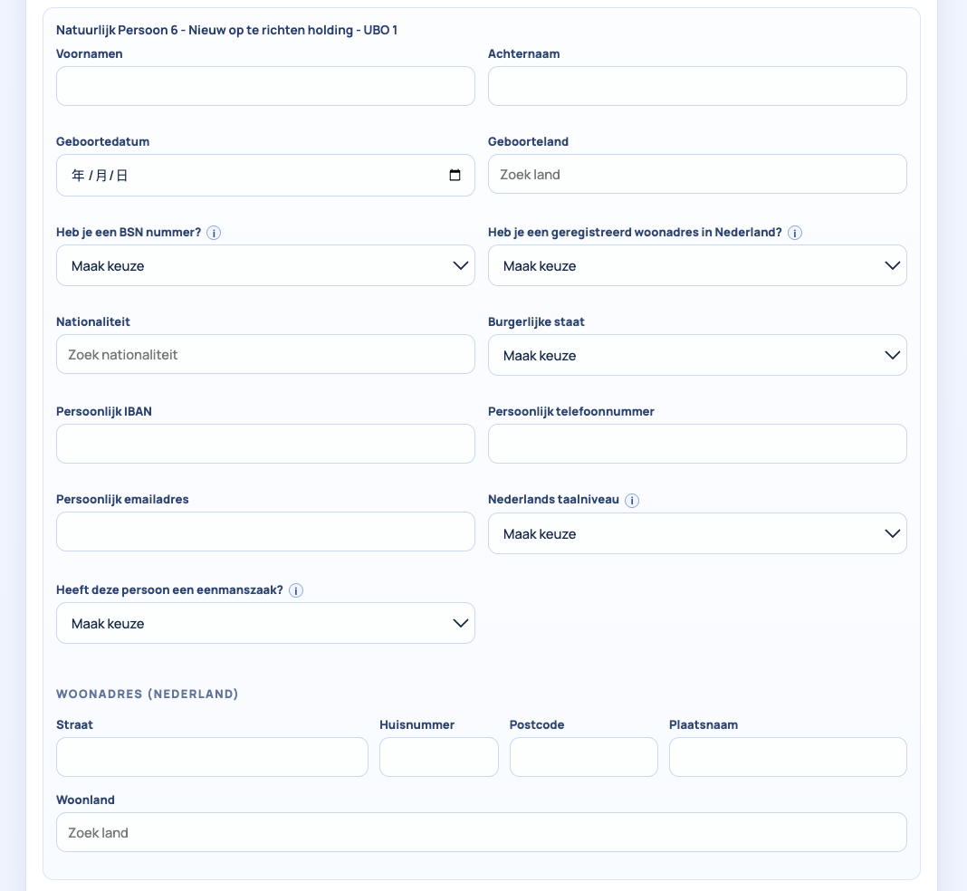
- Upload
  - cannot upload multiple files one by one, they need to select at one time, either we need to change to make it possible to upload different files one by one, or we need to write a reminder that they need to select all files together
I prefer the first solution, since the second one will be difficult for some of the phone users
- indienen
  - need to add check box + Ik ga akkoord met de Privacyverklaring, de Algemene Voorwaarden en de AI-verklaring. Tevens bevestig ik dat ik mijn bestelling en gegevens heb gecontroleerd. I agree to the Privacy Statement, the General Terms and Conditions, and the AI Declaration. I also confirm that I have reviewed my order and details. also the attachment/URL of general ters and conditions +privacy statement

